VISWAJYOTHI COLLEGE OF ENGINEERING & TECHNOLOGY
CST 306 : ALGORITHM ANALYSIS AND DESIGN
Series Test 1 : February 2025
ANSWER KEY
- Find the time complexity of the following function
int fun1(int n)
{ if(n ≤ 1)
return n;
return fun1(n-1)xfun1(n-1);
}
Answer:
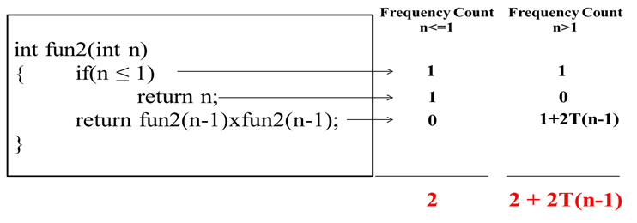
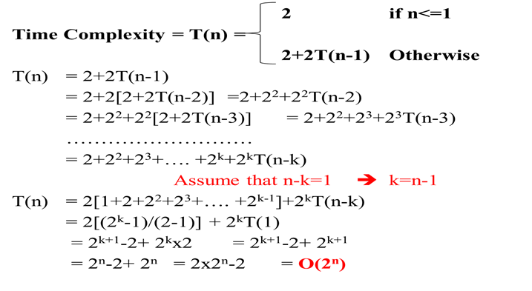
- Find the time complexity of the following function
for(int i=1;i<=n;i++)
{ for(int j=i+1;j<=n;j++)
{
//code
}
}
Answer: The most frequently executing statement is the innermost code. During the first iteration of outer loop that code will execute n-1 times. During the 2nd iteration of outer loop that code will execute n-2 times and so on. During the last iteration it will never execute.
So the frequency count of that code = (n-1) + (n-2) + …….. + 0
= (n-1)n/2 = (n²-n)/2
Time Complexity = O(n²)

- Define AVL tree. Explain AVL rotations with examples
Answer:
  - AVL Tree can be defined as height balanced binary search tree in which each node is associated with a balance factor.

  - Balance Factor
    - Balance Factor of a node = height of left subtree – height of right subtree
    - In an AVL tree balance factor of every node is -1,0 or +1
  - There are 4 types of rotations
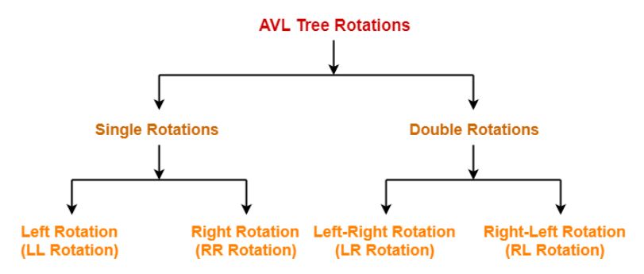
      - Single Left Rotation(LL Rotation)
        - In LL rotation every node moves one position to left from the current position
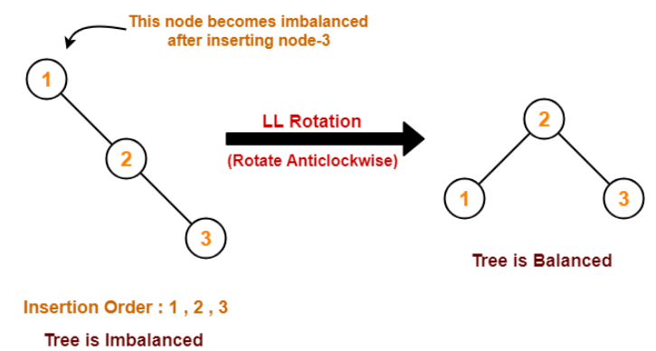
      - Single Right Rotation(RR Rotation)
        - In RR rotation every node moves one position to right from the current position
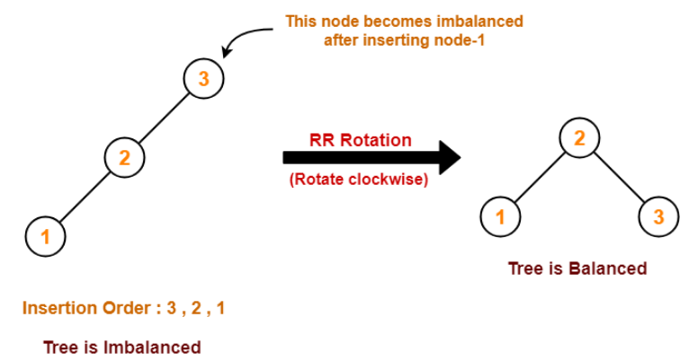
      - Left-Right Rotation(LR Rotation)
        - The LR rotation is the combination of single left rotation followed by single right rotation.
3
1
2
2
-1
0
3
1
2
2
1
0
LL(1)
Insertion Order: 3,1,2
1
2
3
0
0
0
RR(3)
      - Right-Left Rotation(RL Rotation)
        - The RL rotation is the combination of single right rotation followed by single left rotation.
1
3
2
-2
1
0
1
2
3
-2
-1
0
RR(3)
Insertion Order: 1,3,2
2
1
3
0
0
0
LL(1)

- Solve the following recurrence relation using substitution method

- Solve the following recurrence relation using Master’s method

- A. Solve the following recurrence relation using Iteration method
T(n) = 2 if n=1
T(n) = 2T(n/2) + 2n + 3 OtherwiseAnswer:

B) Solve the following recurrence relation using Recursion Tree method
T(n) = 2 T(n/2) + n2

- a) Solve the following recurrence relation using Iteration method
T(n) = 2 T(n/2) + n2

- Solve the following recurrence relation using Recursion Tree method
T(n) = 2T(n/2) + n

- Construct an AVL tree by inserting the keys: 21, 26, 30, 9, 4, 14, 28, 18,15 into an initially empty tree. Delete node 9 from the resultant tree.

b) Explain Asymptotic notations in algorithm analysis
Answer:
      - Asymptotic Notations
        - It is the mathematical notations to represent frequency count. 5 types of asymptotic notations
        - Big Oh (O)
          - The function f(n) = O(g(n)) iff there exists 2 positive constants c and n₀ such that 0 ≤ f(n) ≤ c g(n) for all n ≥ n₀
          - It is the measure of longest amount of time taken by an algorithm(Worst case).
          - It is asymptotically tight upper bound
        - Omega (Ω)
          - The function f(n) = Ω (g(n)) iff there exists 2 positive constant c and n₀ such that f(n) ≥ c g(n) ≥ 0 for all n ≥ n₀
          - It is the measure of smallest amount of time taken by an algorithm(Best case).
          - It is asymptotically tight lower bound

        - Theta (Ɵ)
          - The function f(n) = Ɵ (g(n)) iff there exists 3 positive constants c₁, c₂ and n₀ such that 0 ≤ c₁g(n) ≤ f(n) ≤ c₂ g(n) for all n ≥ n₀
          - It is the measure of average amount of time taken by an algorithm(Average case).

        - Little Oh (o)
          - The function f(n) = o(g(n)) iff for any positive constant c>0, there exists a constant n₀>0 such that 0 ≤ f(n) < c g(n) for all n ≥ n₀
          - It is asymptotically loose upper bound
g(n) becomes arbitrarily large relative to f(n) as n approaches infinity

        - Little Omega (ω)
          - The function f(n) = ω(g(n)) iff for any positive constant c>0, there exists a constant n₀>0 such that f(n) > c g(n) ≥ 0 for all n ≥ n₀
          - It is asymptotically loose lower bound
f(n) becomes arbitrarily large relative to g(n) as n approaches infinity

Insert 10,20,15,25,30,16,18 and 19 in to an empty AVL tree. Delete node 10 from the resultant tree.

- Define the terms best case, worst case and average case complexities.Discuss the best case, worst case and average case complexities of linear search algorithm.
Answer:
      - In certain case we cannot find the exact value of frequency count. In this case we have 3 types of frequency counts
        - Best Case : It is the minimum number of steps that can be executed for a given parameter
        - Worst Case: It is the maximum number of steps that can be executed for a given parameter
        - Average Case: It is the average number of steps that can be executed for a given parameter
      - Example: Linear Search
        - Best Case: Search data will be in the first location of the array.
        - Worst Case: Search data does not exist in the array
        - Average Case: Search data is in the middle of the array.
 | Best Case |  |  | Worst Case |  |  | Average Case
 | S/E | FC | TFC | S/E | FC | TFC | S/E | FC | TFC
Algorithm Search(a,n,x) | 0 | 0 | 0 | 0 | 0 | 0 | 0 | 0 | 0
{ | 0 | 0 | 0 | 0 | 0 | 0 | 0 | 0 | 0
for i:=1 to n do | 1 | 1 | 1 | 1 | n+1 | n+1 | 1 | n/2 | n/2
if a[i] ==x then | 1 | 1 | 1 | 1 | n | n | 1 | n/2 | n/2
return i; | 1 | 1 | 1 | 1 | 0 | 0 | 1 | 1 | 1
return -1; | 1 | 0 | 0 | 1 | 1 | 1 | 1 | 0 | 0
} | 0 | 0 | 0 | 0 | 0 | 0 | 0 | 0 | 0
 |  |  | 3 |  |  | 2n + 2 |  |  | n+1
Best Case Complexity = 3 =Ω(1)
Worst Case Complexity = 2n + 2 = O(n)
Average Case Complexity = n+1 = Ɵ(n)

